**PD1 Week 2 - Worksheet**

**TASK 1 Consider how you could divide the sentences below into two distinct groups. Once they are divided into two groups, give each group a title that would best represent the sentences within.**

1. I just can’t do it.
2. We lost because we’re terrible at this game.
3. I can’t speak Spanish, but I can learn it.
4. This is too difficult. I give up.
5. There’s no such thing as bad weather, only bad clothing.
6. I know my answer is wrong, but I’d like to try answering the question.
7. I’ve always done it this way, and I always will.
8. Why bother?
9. I’ve never seen it done like that before, show me how.
10. I failed the first time, but now I know why so I can fix it.

**TASK 2 Watch the video (https://www.youtube.com/watch?v=3vz6HU1LlOU) and consider the advice given by the stories. Which ones do you think demonstrated a pathway to growth?**

Jordan The Simpsons Elon Musk

Dr. Phil The Ride Home The Pursuit of Happyness

**TASK 3 Homework: What are 3 things that you wish to improve your mindset about? What are the steps you can take to change your attitude about them?**

***In class*** 🡪

1. *Item from slide 6 to be improved:*

*Steps:*

1. *Item to be improved:*

*Steps:*

***Homework*** 🡪

1. *Item to be improved:*

*Steps:*

**TASK 4 What are some common stressors in life? Complete the chart below with your group with as many stressors as you can think of. Then answer the questions.**

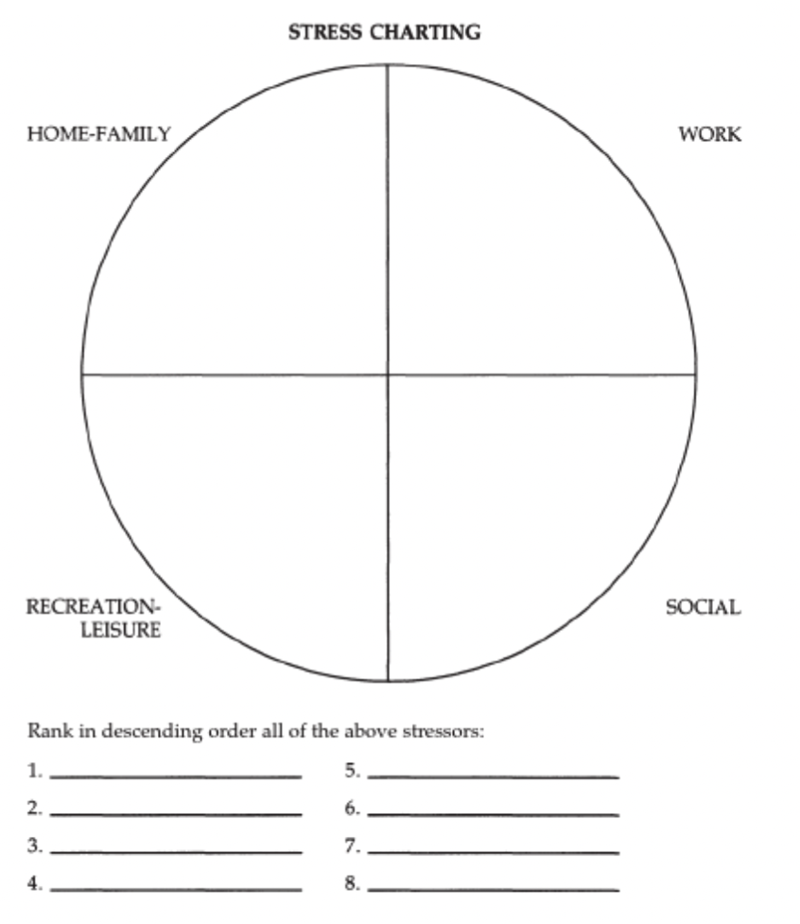

*Raber, MF, & Dyck, G 1993, Managing Stress for Mental Fitness, Course Technology Crisp, Menlo Park. Available from: ProQuest Ebook Central. [19 January 2022].*

1. Which of these stressors affects you the most in your daily life?
2. Do you think you handle stress well? Why/not?
3. What are some things we can do to manage stress in our lives?

**TASK 5 Follow the instructions below to access the stress management quiz on Career Zone**

1. *Log in to your VLE account (*[*https://arulondon2.org/vle/login.php*](https://arulondon2.org/vle/login.php)*)*
2. *Click on the link to the Career Zone Website:*

1. *You can also access that on your main page of the VLE*

1. *Once you’re on the website, look on the drop-down menu entitled ‘Step 1: Explore & Decide’, then select Career Assessment*

1. *Scroll down and select the ‘Stress Management’ quiz*

**TASK 6 Watch the video “How to make stress your friend” (**[**https://www.ted.com/talks/kelly_mcgonigal_how_to_make_stress_your_friend**](https://www.ted.com/talks/kelly_mcgonigal_how_to_make_stress_your_friend)**) up to 7.21 then decide which of the statements below is TRUE or FALSE:**

* Kelly McGonigal has always thought about stress in the same way.
* The first study she discusses followed a group of individuals for 8 years to determine the way in which an individual’s perspective about stress impacted their life expectancy.
* The study found that both those who had positive views and those who had negative views of stress had the same death rate over the years.
* Stress is the 15th largest cause of death in the USA.
* McGonigal has the audience participate in a short social stress test to illustrate that stress impacts all participants negatively regardless of their perspective on stress.
* In the Harvard university study, the cardiovascular system of participants was not adversely impacted by stress-inducing situations because they had been trained to respond more positively to stress.
* McGonigal’s ultimate goals is to get the audience to reconsider how they respond to stress.

**TASK 7 Match the strategies below to the relevant conceptual method. Then discuss the questions below:**

1. *Improve your skills in areas like goal setting, time management and conflict management*
2. *Implement a fitness program*
3. *Change job/vocation/location*
4. *Balance work and play*
5. *Set up your job, if possible, so you can work in a variety of different program areas*
6. *Use peer feedback as a way to identify areas for possible changes in functioning*
7. *Quit going to certain meetings*
8. *Seek professional counselling*
9. *Slow down*
10. *Develop social supports that reduce your sense of aloneness*
11. *Relax, learn to loaf a little*
12. *Get enough sleep and rest*
13. *Own your personal stress*
14. *Develop a sense of humour about your situation*
15. *Structure time off from work*
16. *Get adequate and appropriate nutrition*

|  |  |
| --- | --- |
| **Change your internal attitudes/perceptions** | **Change your interaction with the environment** |
|  |  |
| **Change your physical ability to cope** | **Change your environment** |
|  |  |

*Adapted from Raber, MF, & Dyck, G 1993, Managing Stress for Mental Fitness, Course Technology Crisp, Menlo Park. Available from: ProQuest Ebook Central. [19 January 2022]*